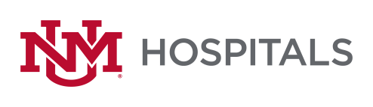

To: All Potential Offerors
From: Sherry L Tackett, Procurement Specialist
Date: 9/1/2022
Subject: RFP P470-22 Interventional Radiology Neuroendovascular Implants & Disposables
Please add this Addendum #1 to the original RFP documents. It shall be the responsibility of the interested Offerors to adhere to any changes or revision to the RFP as identified in this Addendum #1.

The following clarification shall become permanent and made part of the procurement file.

- Section: 1.1: “Awards will be given for a minimum of 3-year duration contract”
Can you provide specific details on what is being awarded and the scope?
Please read Section I: Scope of work in the RFP on page 3
- Will Stryker Neurovascular have the opportunity to present the comprehensive proposal to the UNM team? Yes
- Will the UNM Total Neurovascular Spend be shared with Stryker NV? No
  - We typically have this information communicated during the RFP process, which directly impacts the proposal.
  - Discounts can vary by spend level.
- Page 1, #1: Can you confirm that you only wish to receive hard copies of the proposal?
  - Per Page 2, #3: “only be hand delivered via an express carrier”? Or in person
- Or will digital submission be acceptable? No
Only Hard copies per the instructions on page 1-2 and no emailed copies will be accepted.
  - Would there be a negative to the RFP being sent early (as long as 9/14/2022 is stated)? No
- Will the Award be a Single Vendor, Dual Vendor, etc.? Companies included. No and Varies depending on device
- Section: 5.1.3: “Provide no less than 2 references of customers you have extended into an agreement with” Are you requiring two customer references for Stryker Corporation? Yes
- Has a decision date/vendor notification date been established? No
- In section 5.1.4 it states “The Offeror should provide financial information sufficient for UNMHSC to adequately establish the Offeror’s financial capability to provide and support the scope of work in its Proposal. Such information may take the form of an annual report, banking information and/or guarantees.” Can you expand on what the “guarantee” would look like (i.e. a letter from an executive at the company, etc.)? Yes, a letter will suffice

If there are any questions or inquiries in relation to this Addendum #1, Offerors may contact Sherry Tackett by email SLTaclett@salud.unm.edu

