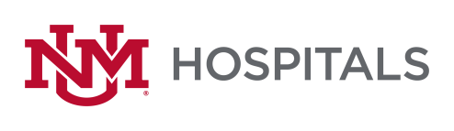

To: All Potential Offerors
From: Sherry L Tackett, Procurement Specialist
Date: 9/1/2022
Subject: RFP P470-22 Interventional Radiology Neuroendovascular Implants & Disposables
Please add this Addendum #1 to the original RFP documents. It shall be the responsibility of the interested Offerors to adhere to any changes or revision to the RFP as identified in this Addendum #1.

The following clarification shall become permanent and made part of the procurement file.
- Section III - Vizient - We have a Sole source Neuro agreement w/Vizient (MS1431) can we leverage those T&Cs? No
- Categories - Can you verify these are all the categories being included?
  - Neuro Embolization
  - Aspiration Catheters
  - Stent Retrievers
  - Micro/Intermediate Catheters
  - Access Catheters
All items related to Neuroendovascular is being included.
- Rebates - In addition to aggressive line item pricing, do you also accept rebates? Yes How do you prefer them structured? That is up to you
- Cross Reference – Do you need a cross reference of products? No
- On Label - We assume you only want us to bid on-label products for ischemic stroke/mechanical thrombectomy/embolization. Please confirm. If this is what you sell for Neuroendovascular items, then yes.
- Decision Making - Can you share the roles that will be part of the decision-making committee? No
- Bidding Website – Is this active? Clicking the link took us to the homepage. http://hospitals.unm.edu/about/proposals.shtml
Please try below
https://unmhealth.org/about/bids-proposals/current.html

If there are any questions or inquiries in relation to this Addendum #1, Offerors may contact Sherry Tackett by email SLTaclett@salud.unm.edu

